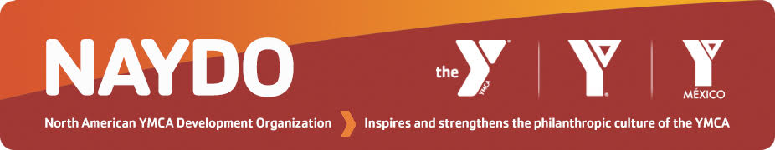
NAYDO Young Professionals
Class of 2023 Program Application Form
Location: Houston, TX
April 11-14, 2023

Deadline: December 6, 2022
Applications accepted after this date on a case-by-case basis

Application Process

Step 1: Make sure your YMCA is a NAYDO Member and that applicant has activated individual membership benefits for the 2022-2023 NAYDO Year. If unsure, request status from info@naydo.org
Step 2: Register for the Conference
- No extra fee for the Young Professionals Program
- Mark Young Professionals Program on registration form
Step 3: (Optional step) IF NEEDED
- Complete & Submit the Conference Financial Assistance Form
- Mark Financial Assistance Applicant Staff on registration form & pay $50 application fee
Step 4: Complete this Young Professionals Application Form
- Supervisor and Applicant must complete form and both must sign it

Step 5: Complete steps 1-4 by December 6, 2022
- Applicant and supervisor will be notified by email in late December 2022 of decision

For questions or more information, contact:
Bruce Ham, NAYDO Young Professionals Chair bruce.ham@ymcatriangle.org

Courtney Cordero, NAYDO Young Professionals Alumni Coordinator ccordero@ymcasd.org

Mary Zoller, NAYDO Operations & Conference info@naydo.org, 504 858 3379

Part I: Personal Information

Applicant’s Name________________________________NAYDO Member YES NO

Supervisor’s Name__________________________Supervisor’s Title_____________________

Supervisor’s Email____________________________________Phone____________________

Current YMCA Position Title _________________________________________________
Briefly describe your job responsibilities:

Length of time in this position ____yrs
Length of time involved in the YMCA ____yrs (mark as many as apply)
Child/Youth or Teen Program Participant Part-Time Staff
Current or Past YMCA Volunteer Full-Time Staff

Length of time involved in financial development OR communications OUTSIDE of the Y: ___

Description of work:

YMCA Association Name ______________________________________

Branch Name (if applicable) _____________________________________

Address _____________________________________________________

City ______________________ Province/State ________ Postal/Zip Code ____________
Phone _______________________
Email _______________________________________

Have you ever attended a NAYDO Conference before? YES NO
If you participated in NAYDO 2021 Virtual Conference include that here

If YES, list year(s) or cities:

Part II: Personal Goals

Please indicate the 3 areas in which you would like to increase your knowledge and/or improve your skill level as 1, 2, and 3 in priority order.
___Develop an effective Annual Campaign including recruitment and training of campaigners
___Learn the steps to developing, launching and running a successful Capital Campaign
___Build a Major Gifts program for your YMCA that is donor-centered and focused on relationship building
___Create and deliver comprehensive Marketing and Communications strategies to more effectively share the YMCA story with stakeholders
___Gain a better understanding of the profile of a strong fundraising Board and the volunteer's role in fostering a culture of philanthropy
___Engage with Volunteers to foster better relationships, as well as clearly define roles, expectations and philanthropic commitment
___Understand how to create and grow a Planned Giving program
___Other (please describe)

Part III: Personal Impact (Required)
In a paragraph below, describe what impact you believe you could have on creating or supporting a culture of philanthropy at your YMCA through your participation in the NAYDO Conference and, in particular, the Young Professionals Program.

Part IV: Understanding of Process and Expectations

To complete the application process for the NAYDO Young Professionals Program, please read and sign below confirming that you understand the following conditions:
- I have registered online for the 2023 NAYDO Conference. I am aware that there is no additional fee* for my participation in the Young Professionals Program but it does require my YMCA to pay the registration fee, travel and lodging costs that all attendees pay. If needed, I can apply for financial assistance following the same process used by all conference attendees described at www.naydo.org. Deadline to apply for conference assistance is December 6, 2022. * The Philanthropy Live! Project for Young Professionals on Tuesday night though optional does include $20 to cover the cost of dinner. Class members are encouraged to participate; if $20 is a barrier to participation mention this on this application form.
- I understand I will be notified by email in late December 2022 of the status of my application and will need to confirm acceptance by email.
- As a participant in the Class of 2023, I am authorizing use of my comments in NAYDO promotional pieces including e-blasts, website, brochure, the Developments newsletter, mobile app, and other applicable communications.
- I understand that space is limited in the Young Professionals Program and even if I meet all criteria and submit this application by the December 6, 2022, deadline it is possible, I may not be selected.

Part V: Supervisor’s Recommendation/Comments (REQUIRED)

Applicant E-Signature & Date Supervisor’s E-Signature & Date

__________________________ ____________________________

Scan and email this form by December 6, 2022 to Mary Zoller: info@naydo.org
Use info@naydo.org for questions about the form or call the NAYDO Office, 504 858 3379

