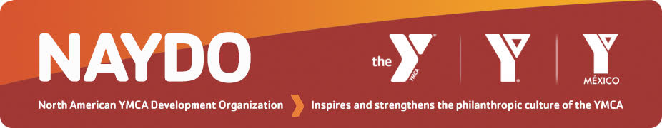
NAYDO Young Professionals
Class of 2022 Program Application Form
Location: Tampa, Florida
April 6-9, 2022

Deadline: December 6, 2021
Applications accepted after this date on a case-by-case basis

Application Process

Step 1: Make sure your YMCA is a NAYDO Member and that applicant has activated individual membership benefits for the 2021-2022 NAYDO Year. If unsure, request status from info@naydo.org
Step 2: Register for the Conference
- No extra fee for the Young Professionals Program
- Mark Young Professionals Program on registration form
Step 3: (Optional step) IF NEEDED
- Complete & Submit the Conference Financial Assistance Form
- Mark Financial Assistance Applicant Staff on registration form & pay $50 application fee
Step 4: Complete this Young Professionals Application Form
- Supervisor and Applicant must complete form and both must sign it

Step 5: Complete steps 1-4 by December 6, 2021
- Applicant and supervisor will be notified by email in late December 2021 of decision

For questions or more information, contact:
Bruce Ham, NAYDO Young Professionals Chair bruce.ham@ymcatriangle.org

Courtney Cordero, NAYDO Young Professionals Alumni Coordinator ccordero@ymcasd.org

Mary Zoller, NAYDO Operations & Conference info@naydo.org, 504 464 7845

Applicant’s Name________________________________NAYDO Member YES NO

Supervisor’s Name__________________________Supervisor’s Title_____________________

Supervisor’s Email____________________________________Phone____________________

Part I: Personal Information

Current YMCA Position Title _________________________________________________
Briefly describe your job responsibilities:

Length of time in this position ____yrs
Length of time involved in the YMCA ____yrs (mark as many as apply)
Child/Youth or Teen Program Participant Part-Time Staff
Current or Past YMCA Volunteer Full-Time Staff

Length of time involved in financial development OR communications OUTSIDE of the Y: ___

Description of work:

YMCA Association Name ______________________________________

Branch Name (if applicable) _____________________________________

Address _____________________________________________________

City ______________________ Province/State ________ Postal/Zip Code ____________
Phone _______________________
Email _______________________________________

Have you ever attended a NAYDO Conference before? YES NO
If you participated in NAYDO 2021 Virtual Conference include that here

If YES, list year(s) or cities:

Part II: Personal Goals

Please indicate the 3 areas in which you would like to increase your knowledge and/or improve your skill level as 1, 2, and 3 in priority order.
___Develop an effective Annual Campaign including recruitment and training of campaigners
___Learn the steps to developing, launching and running a successful Capital Campaign
___Build a Major Gifts program for your YMCA that is donor-centered and focused on relationship building
___Create and deliver comprehensive Marketing and Communications strategies to more effectively share the YMCA story with stakeholders
___Gain a better understanding of the profile of a strong fundraising Board and the volunteer's role in fostering a culture of philanthropy
___Engage with Volunteers to foster better relationships, as well as clearly define roles, expectations and philanthropic commitment
___Understand how to create and grow a Planned Giving program
___Other (please describe)

Part III: Personal Impact (Required)
In a paragraph below, describe what impact you believe you could have on creating or supporting a culture of philanthropy at your YMCA through your participation in the NAYDO Conference and, in particular, the Young Professionals Program.

Part IV: Understanding of Process and Expectations

To complete the application process for the NAYDO Young Professionals Program, please read and sign below confirming that you understand the following conditions:
- I have registered online for the 2022 NAYDO Conference. I am aware that there is no additional fee for my participation in the Young Professionals Program but it does require my YMCA to pay the registration fee, travel and lodging costs that all attendees pay. If needed, I can apply for financial assistance following the same process used by all conference attendees described at www.naydo.org. Deadline to apply for conference assistance is December 6, 2021.
- I understand I will be notified by email in late December 2021 of the status of my application and will need to confirm acceptance by email.
- As a participant in the Class of 2022, I am authorizing use of my comments in NAYDO promotional pieces including e-blasts, website, brochure, the Developments newsletter, mobile app, and other applicable communications.
- I understand that space is limited in the Young Professionals Program and even if I meet all criteria and submit this application by the December 6, 2021, deadline it is possible, I may not be selected.

Part V: Supervisor’s Recommendation/Comments (REQUIRED)

Applicant E-Signature & Date Supervisor’s E-Signature & Date

__________________________ ____________________________

Scan and email this form by December 6, 2021 to Mary Zoller: info@naydo.org
Use info@naydo.org for questions about the form or call the NAYDO Office, 504 464 7845

