The YMCA of Greater Flint
Y Safe Places Prospectus
Only 10.9% of 3rd Graders in the Flint Community Schools tested as proficient in English Language Arts in 2019. 9.7% tested proficient in Mathematics.
“Third grade has been identified as important to reading literacy because it is the final year children are learning to read, after which students are ‘reading to learn.’ If they are not proficient readers when they begin fourth grade, as much as half of the curriculum they will be taught will be incomprehensible."
More than 15 million students (about twice the population of New Jersey)—including approximately 3.7 million middle schoolers —are alone and unsupervised between 3 and 6 p.m., the peak hours for juvenile crime and experimentation with drugs, alcohol, cigarettes, and sex.
If Flint were to receive a report card with grading on the emotional, mental, and physical health of its children, it would receive FAILING marks. Children struggle at school, and they struggle at home. The Flint Water Crisis and Covid-19 Pandemic has laid bare the inequities that exist in our community. Our most vulnerable populations – youth from lower to moderate income homes - lack the resources to maintain any quality of life or survive these crises.
With failure on a systematic level, youth need organizations that can provide holistic care, offering academic interventions, health interventions, and social emotional growth. The YMCA of Greater Flint is that organization, committed to helping youth for over 100 years.

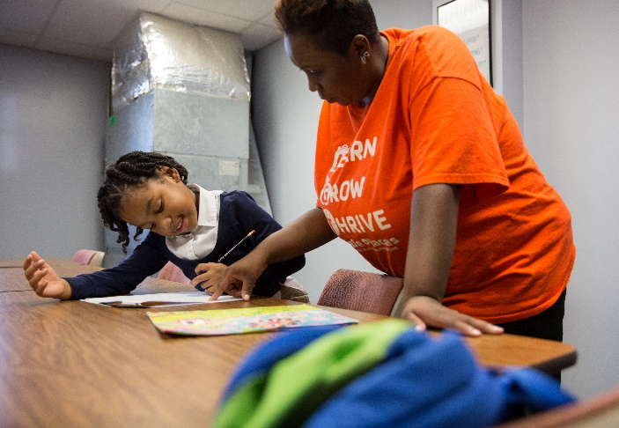
Project Description
Y Safe Places is a FREE year-round youth enrichment program that operates Monday through Friday from 4-7 pm at community centers in the city of Flint. The program provides crucial childcare for families in need making certain that out of school time is filled creatively and constructively, granting youth the access to express their skills, talents, and interest in sports, healthy activity, and play. Utilizing the evidence based physical activity program CATCH and healthy eating guidelines known as HEPA, students receive 30 minutes of varied physical activity, a healthy snack and supper, and homework assistance. Youth are encouraged to challenge their bodies and minds to reach their greatest potential. Parental education opportunities and family fun events are also held quarterly to engage the entire family. The goal of the program is reduced to three simple words: Learn, Grow, Thrive.

Our Community
The city of Flint has faced and continues to combat several economic and health crises that have spanned several decades. Since a population high in the 1970’s, Flint has lost half of its population due to job loss and urban blight. General Motors who once provided 80,000 jobs to the residents of Genesee County now provide just 8,200. In 2014, under state emergency management the municipal water source was switched to water that was not properly treated and led to widespread lead contamination to residents and people working in Flint.
Many negative social determinants of health exist in our community; economic inequality and disparity meaning 26% of county youth and 61% of youth in the city of Flint live in poverty. Our community lacks resources and support for the 44% of children in single parent homes in an unsafe city where violent crime is more than 10 times likely than other US (United States) cities. Flint and Genesee County have some of the highest rates of obesity and food insecurity in the nation. Genesee County ranks 80th out of 83 counties in Michigan for quality of life. Genesee County residents experience higher rates of chronic disease and chronic obesity than their national peers.

Resident Priorities
For the past three years, the Charles Stewart Mott Foundation’s Focus on Flint initiative has conducted a Quality of Life Survey, providing important data on the needs of Flint Residents. This study has provided an important snapshot into the priorities of residents around health, education, and other issues. It found:
- The top concern from the survey was crime/safety issues (48%)
  - Y Safe Places offers a safe program for youth to escape dangerous situations at home or in their neighborhood
- 75% of residents believe the quality of public education in Flint is a serious concern
  - Y Safe Places programs provide support to youth and families through academic interventions
  - The Afterschool Program provides homework assistance to youth daily
  - Power Scholars Academy is an intensive 8-week program to mitigate learning loss
- 59% of residents believe access to healthy foods is of serious concern
  - Youth attending Y Safe Places program receive a daily meal and snack following nationally guidelines for healthy eating

According to the Afterschool Alliance, unmet demand for Afterschool programs in Michigan is high, with every child in afterschool, 4 are waiting for an available program. Nationally, sixty-seven percent of parents living in a community of concentrated poverty reported finding a program to be a challenge; sixty-one percent reported affordability to be a problem. Our program expands accessibility and affordability.
There is an overwhelming number of Flint Community School student in the 3rd, 8th and 11th grades that are not proficient in English and math. These benchmarks are indicators of later success in life including career readiness, attending higher education, and positive health outcomes. The trend reigns true for most of the Genesee Intermediate School district schools. YMCA programing like Safe Places is well poised to alleviate the challenges of low performing students, in academic achievement, chronic absenteeism, and dropout rate.

Goals and Outcomes
The goal of Y Safe Places is to ensure youth in metro Flint fill out of school time creatively and constructively, granting them the access to express their skills, talents, and interest in sports, healthy activity and play while enriching and improving academic outcomes.
- To provide quality care for all children; in a safe, structured environment
- To improve quality of life, health, and self-esteem
- To support and strengthen the family unit
- To help children develop to their fullest potential
- To teach the importance of physical activity throughout life

Additional Programming
In addition to the capstone programming of the free Afterschool Program, several other programs sit under the Y Safe Places umbrella. All programs share several key characteristics – Free programs, for Flint inner-city youth, that exposes youth to engaging enrichment activities that improve their mental, physical, and emotional health. These additional programs are:
Winter Sports Program – This FREE 6-week program introduces youth to winter sports like down-hill skiing and cross-country skiing. All associated costs of the program including equipment rental, lift tickets, and transportation are covered by the program. Appropriate outdoor wear is donated for students to wear as well.
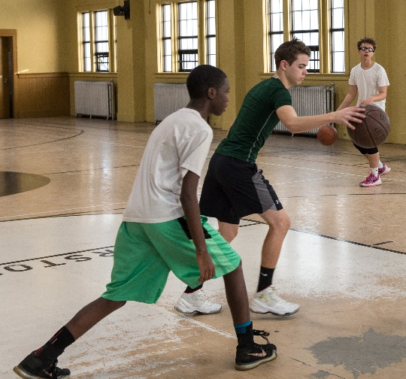
Saturday Morning Basketball Program – This FREE 8-week program offers youth a chance to improve their basketball skills while also presenting lessons in STEM, fair play, and sportsmanship.
Power Scholars Academy – This FREE 8-week program utilizes the Bell Xcel curriculum, an evidence-based program taught by certified teachers to improve learning loss in 3rd and 4th graders and bring struggling students to their peers' scholastic levels.

Evaluation
Evaluation is an important indicator of program health and one that the YMCA takes very seriously. Our program utilizes three forms of evaluation that allow us to benchmark the program from year to year, but also with similar programs on the local, state, and national level.
Self-Perception Profile – Students in the program are administered a self-perception profile at the beginning and end of the academic session. This is based on a profile developed by Susan Harter and is proctored to all Flint area youth development programs that receive funding from Ruth Mott Foundation. This provides local benchmarks.
Parent Survey – Parents in the program are asked to fill out a survey in February each year designed and administered by the Altarum Institute. This survey is given to all parents of participants in 26 YMCA branches in the state of Michigan. This also us to compare to other YMCA programs in the state.
STAR Assessment – This assessment is administered to students in the Power Scholars Academy (PSA) to assess their reading and math proficiency. It is given at the start and finish of each session of PSA. This is used to compare to other programs using the Bell Xcel Curriculum across the nation.

Previous Successes and Best Practices
The youth programs at the YMCA of Greater Flint have successfully operated for several years and their successful operation has allowed us to grow in participant numbers and program sites. Parents routinely report that youth have better discipline at home and school, improved grades, and healthy eating habits. YMCA programs have a national reputation for excellence. They are currently operating in 40 states. Overall, the afterschool programs of the YMCA:
- Improved social-emotional skills 70%
- Increase in school attachment 54%
- Improved school conduct 57%
- Increased self-efficacy 67%

Additionally, youth who participate in Summer Enrichment programs through the YMCA on average:
- Have 2.5 month gains in reading
- Have 2.5 month gains in math skills
- 92% of parents report improvement in scholars’ confidence and attitude toward school and learning.

YMCAs across the nation have a proven record of accomplishment of success. Utilizing these best practices, the YMCA of Greater Flint will help Flint youth have the same positive outcomes.

Key Staff
Monica Holmes-YMCA of Greater Flint Safe Places Director. Where she focuses on Youth Development, Healthy living, and Social Responsibility. Monica, partners with a variety of community organizations to provide cultural and educational enrichment activities and skill building. Areas of focus include academics, sports, performing arts, technology, arts and crafts, nutritional and physical engagement. Monica has worked at the YMCA in many capacities. She has worked and coordinated a Bitty basketball program, teaching kids from ages 5-13 fundamentals skills and building self-esteem.
Monica has a degree in Bachelor of Science in Criminal Justice. Monica has worked at New Paths Inc as a Senior Residential Supervisor/ Advisor & Clinical Technician. She has performed in multiple positions in the treatment of behavioral health while providing individuals an opportunity to change their lives.

YMCA of Greater Flint Mission
The mission of the YMCA of Greater Flint is to put Christian principles into practice through programs that build a healthy spirit, mind, and body for all.
Our vision at the YMCA of Greater Flint is to make Y services available to everyone in our community. Programs at the Y improve the wellness of the whole person, body, mind, and spirit, in a welcoming environment that provides quality equipment, programs, and service. The YMCA of Greater Flint serves people and families of all ages, income levels, and physical conditions.

Additional Resources
To ensure that our youth programs are sustainable and successful the YMCA engages several community resources.
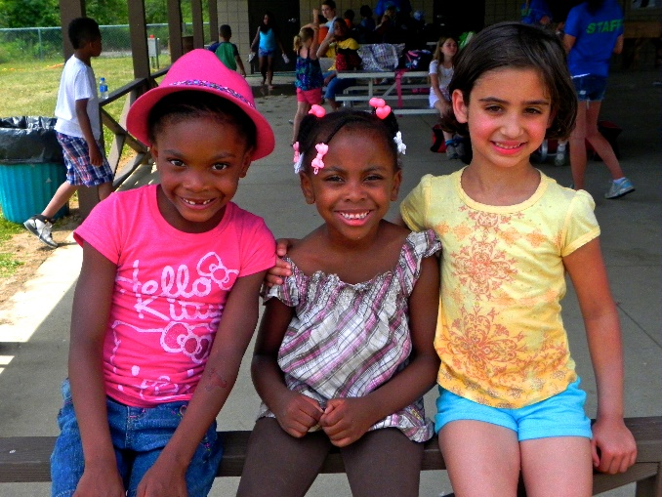
Faith Based Organizations – Working with Faith Based Organizations around the city has allowed us to support and expand on their outreach missions to create micro-community centers in neighborhoods that can address a magnitude of concerns. Often already participating in neighborhood engagement with their congregants through food giveaways, literacy training, and health fairs, the Y brings the unique expertise of youth programs to these sites providing a holistic experience for residents. Attendance at our sites also increase because of the multitude of services offered for the whole family. These organizations also provide passionate volunteers to help with programs.
Hurley Medical Center – A close partnership with Hurley Medical Center and the YMCA of Greater Flint exists and supports our mutual mission of positively affecting the health of residents in Genesee County. Hurley’s medical and wellness staff provide invaluable training and resources to improve the health outcomes of the children in our youth programs.
School Districts – The YMCA has cultivated strong relationships with the Flint Community Schools and local charter schools. We work with the schools to identify and address critical need areas. Additionally they allow us to communicate with their students about the free programming opportunities through the Y.
YMCA of the USA – This national organization which the YMCA of Greater Flint is a part of, is a source of technical assistance, funding, and best practices. YUSA connects our organizations with other Y’s offering similar programming as well as researching trends and best practices in youth development.

Scope and limitation of the project
The Y Safe Places program currently serves 193 students in that reside in and around the city of Flint.

Sustainability
To maintain the improvements in academics and health the K-12 youth have in our program, we will focus on three specific sustainability factors: foundational support, advocacy, and annual fund support. To accomplish these three tasks our organization has one full-time and one part time development staff to ensure that all the programs of the YMCA of Greater Flint can be sustained by the generous donations of foundations, businesses, and members. Over the past year, we have been able to secure large-scale grants from foundations and state departments such as the Ruth Mott Foundation, Michigan Department of Education, YMCA of USA Strategic Fund, and Michigan Department of Health and Human Services. Our YMCA State Alliance has engaged in advocacy efforts to included YMCA out of school time programs as line items in the state budget ensuring operational support for youth programs. Lastly, we continue to operate a successful annual fund campaign that last year raised over $446,000. This campaign funds many of the services at the Y including subsidized youth, family, and senior memberships, swim lessons, camperships to both Camp Boomerang and Camp Copneconic and our Y Safe Places program.

Media
Website: www.flintymca.org
Facebook: https://www.facebook.com/FlintYMCA
Twitter: https://twitter.com/YMCA_of_Flint @YMCA_of_Flint
Instagram: https://www.instagram.com/YMCA_of_Flint

2019 M-STEP Results
National Conference of State Legislators, 2019. https://www.ncsl.org/research/education/pre-kindergarten-third-grade-literacy/
Issue Brief No. 65 Keeping Kids Safe and Supported in the Hours After School, Afterschool Alliance
KIDS COUNT Data Center from the Annie E. Casey Foundation, https://datacenter.kidscount.org
University of Wisconsin Population Health Institute, County Health Rankings, https://www.countyhealthrankings.org/

