A Day Tue Give
Giving Tuesday Background
#GivingTuesday is a movement that has become a global phenomenon. Started in 2012 by a United Nations foundation based in the U.S. and coming to Canada in 2013, #GivingTuesday is a day marked for giving and volunteering, taking place each year following Black Friday and Cyber Monday (US). #GivingTuesdayCa and #GivingTuesday trended all day on Twitter with 100,000+ mentions, and there were proclamations across the country highlighting the day in 2015.
In 2015, the YMCA of Simcoe/Muskoka recognized GivingTuesday as an opportunity to engage our stakeholders and raise our charitable profile. There was no financial goal and the day was used merely to spark conversation and engage people on social media.

In 2016, the YMCA of Simcoe/Muskoka decided to use GivingTuesday as an opportunity to launch its community campaign. More importantly, it was a chance to empower staff at all levels to be a part of an association wide campaign, and have direct impact. These peer to peer appeals would not only spark conversations and shares, it would kick start year-end appeals and support our signature event, Move To Give. This campaign was also an opportunity to use graphic elements created for the most current Annual Report and really helps explain what the YMCA does.

Campaign Objectives
- Social Media Instigators: Get 50 staff and/or volunteers to be social media instigators, promoting #GivingTuesday.
- Campaign Financial goal: To raise $6,500 in one day, representing 1% of our Annual Campaign goal
- Simplify the donation process by making access less than 2 clicks and providing pre-selected amounts.

Social Media Instigators
Too often we rely on leadership to be an organization’s connectors, as they often have the most extensive network. However, it’s the frontline staff who have the best stories and experiences with the people who are most impacted by the work we do. The GivingTuesday campaign was the perfect opportunity to connect our philanthropic cause to frontline staff. In order to support our instigators, we created a toolkit for sharing information on social feeds. The toolkit consisted of:
- Profile images for social media accounts: Facebook, Twitter, Instagram
- Cover/Header images for social media accounts: Facebook, Twitter
- Social Media posts for all platforms, including text and images
- Email/private message scripts for personal asks.
- How to videos addressing the 5-W’s for the social instigators
- Video – “How do I Build Healthy Communities?”
Facebook:
Sample Posts:
- “We make a living by what we get. We make a life by what we give.” – Winston Churchill. Help the #YMCASM build healthy communities by donating on #GivingTuesdayCA. http://bit.ly/2fi6xBG
- “The value of a man resides in what he gives and not in what he is capable of receiving.” – Albert Einstein. Help me support the #YMCASM in reaching their #GivingTuesdayCA goal and make a donation. http://bit.ly/2fi6xBG
- How do you like to give back to your community? Support #YMCASM on #GivingTuesdayCa and donate now! http://bit.ly/2fi6xBG
- I invite all of you to join the #GivingTuesdayCA movement to celebrate giving and encourage people to Feel Great Giving during the Holiday Season. http://bit.ly/2fi6xBG
Sample Graphics:
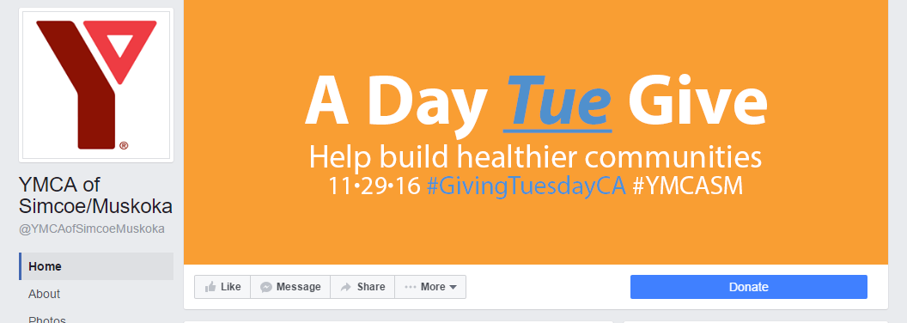
Video – “How do I build Healthy Communities?”
By featuring staff from across the diverse program areas offered by the YMCA of Simcoe/Muskoka, we were able to emphasize our cause – Building Healthy Communities. This 90 second video concept featured staff, including the CEO, connecting our programs to our cause and saying thank you to our donors.
  - Link: https://youtu.be/nz-G7csDPAQ
  - In the week following GivingTuesday, the video was viewed 3,883 times, by 3,510 unique viewers
  - Video reach was 11,759 people
  - 289 people engaged with this post, with 197 reactions (156 from shares), 18 comments (16 from shares)
  - This post was shared 74 times!

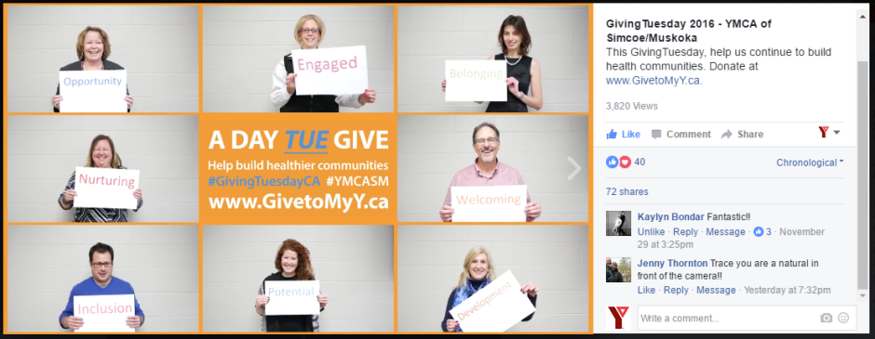
Twitter:
Sample posts:
- Ever thought u could "give back" a little more? What are u waiting for? http://bit.ly/2fxQ5OD #GivingTuesdayCa @YMCASM
- Feel Great Giving. http://bit.ly/2fxQ5OD #GivingTuesdayCa @YMCASM
- We are so grateful for your support. We couldn’t build healthier communities without you. http://bit.ly/2fxQ5OD #GivingTuesdayCa @YMCASM
Sample Graphics
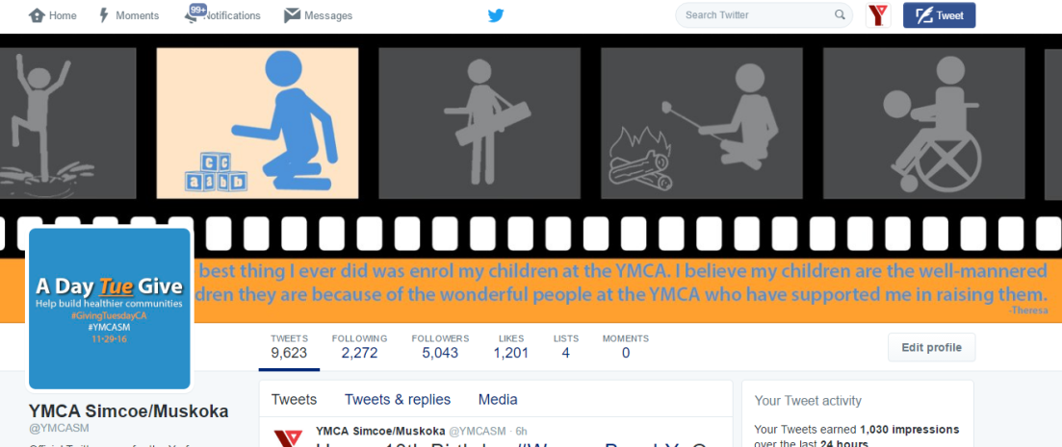

YMCA of Simcoe/Muskoka Twitter Profile
- 2,400 impressions (compared to the average impressions per day during the prior 28 day period was 1,300 impressions per day)
- 2.6% engagement rate (compared to an engagement rate of 1.1% of the prior 28 days)
- 4 donor clicks (compared to the average clicks per day are 2 during the prior 28 days)
- 27 retweets (compared to average retweets per day was 6 during the prior 28 days)
- 23 likes (compared to the average likes per day was 5 during the prior 28 days)
Total Daily Reach:
- 27 posts were made on Twitter by 17 unique users using the hashtag #YMCASM on November 29.
- Total reach was 10,785, making 16,107 impressions.
Overall
Over 200 staff supported GivingTuesday through social media posts, making phone calls, sending emails and conducting face to face asks – 4 times the initial goal set out in the strategic planning process.
Campaign Financial Goal
The YMCA of Simcoe/Muskoka raised over $12,000 in pledged and cash gifts because of the GivingTuesday 72 hour campaign (November 29, 2016 – December 1, 2016). This represented a huge lift, compared to the prior year’s campaign, which was focused primarily on awareness, and didn’t drive donations to the YMCA.
 | Goal | % of Campaign Goal | Actual | Actual % of Campaign Goal
Dollars raised | $6,500 | 1% | $12,000 | 1.85%

 | Goal | Actual
Donors | 50 | 51

Simplify donation process
Prior to GivingTuesday, the donation page was generic and stark. It was white fillable form with the YMCA logo. This campaign was an opportunity to revamp the secure giving page, to speak to impact and be sure the form was easier and when you landed there, the images serve as an opportunity to say thank you, for considering the YMCA, and hopefully giving.

As part of our strategy, we made sure to mirror the look and feel of the campaign on the landing page, to ensure that when someone clicked on a link from a shared post or email, they would understand why they were directed there.

Aside from trackable links on social media, we used the custom URL GiveToMyY.ca as a redirect, to ensure that it was easy to remember and convert.
Budget and Human/Other Resources
The philanthropy and marketing teams worked on this project collaboratively.
- Brian Shelley, Vice President, Philanthropy, Brand and Community Development
- Lindsay Harrison, Coordinator, Marketing – Project lead
- Alex McIntosh, Manager, Major Gifts – Project Lead
- Susan Kulkarni, Manager, Major & Planned Gifts
- Pamela Marck, Manager, Marketing & Communications
- Adam Brown, Marketing & Graphic Design Specialist
This was a viral campaign, with limited budget. All creative was created in house, re-using assets from our annual report project. $1750 was devoted to the development of the strategy for GivingTuesday. The total spent on the campaign was $100 in google re-marketing, and $25 in boosted posts. ROI was 540%.
Conclusion
With an emphasis on our charitable cause, we were able to successfully communicate impact of the work that we do. By optimizing the digital tools we use every day, we empowered staff to use their voices and networks to promote our stories and successes and create value to potential donors. We exceeded our goals and will build on this in future campaigns.

